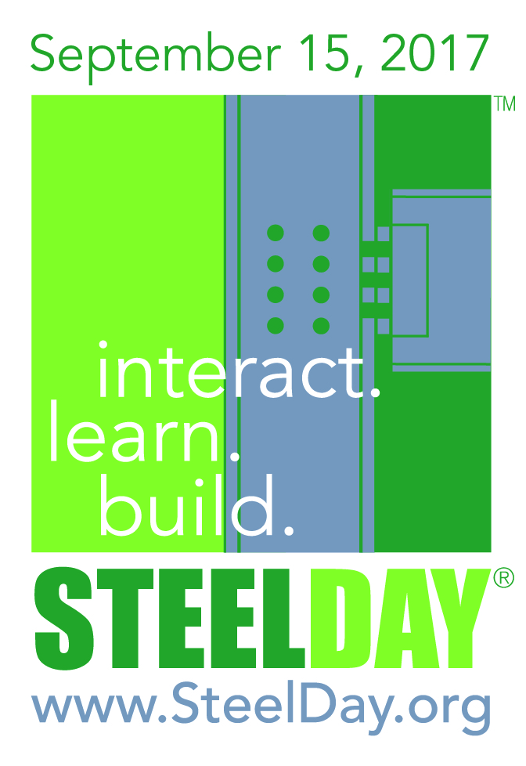
Opening Address, Suitable for All Events.
Welcome and Happy SteelDay!
SteelDay is an interactive day with the structural steel industry. This is the ninth annual SteelDay following on from the phenomenal success of 2016 when more than 8,000 people toured facilities or listened to presentations at approximately 200 events throughout the country.
Today, across the nation, around 200 events are taking place with an estimated 10,000 people attending. Steel fabricators, mill, service centers, galvanizers, HSS producers, bender-rollers, detailers, erectors, machinery manufacturers and software providers are opening their facilities, jobsites and offices offering tours and presentations, inviting the AEC community, general public, universities and schools to see how our industry contributes to America’s built environment.

Every building professional wants to reduce their risk, manage their costs, and these
days also be sensitive to the environment. Building with structural steel is an obvious
decision:

- It’s Sustainable: Among its other sustainable attributes, steel is the most recycled
material on the planet
- It’s Available, domestically: More than 90% of structural steel is made right here in
the United States.
- It’s Fast: To fabricate and erect, which means reduced schedules and earlier
revenue generation.
- It’s Economical:– to install and maintain – meaning an improved bottom line.

SteelDay is the industry’s largest networking and educational event – we want to share
the way we do things and how we use technology. We want to invite questions and
discuss how our industry can help you be more efficient and productive. And perhaps we
also just want to show off a little. This is your chance to get to know the structural steel
industry, us, personally.

Thanks for being here. Enjoy your day and please, ask questions….

